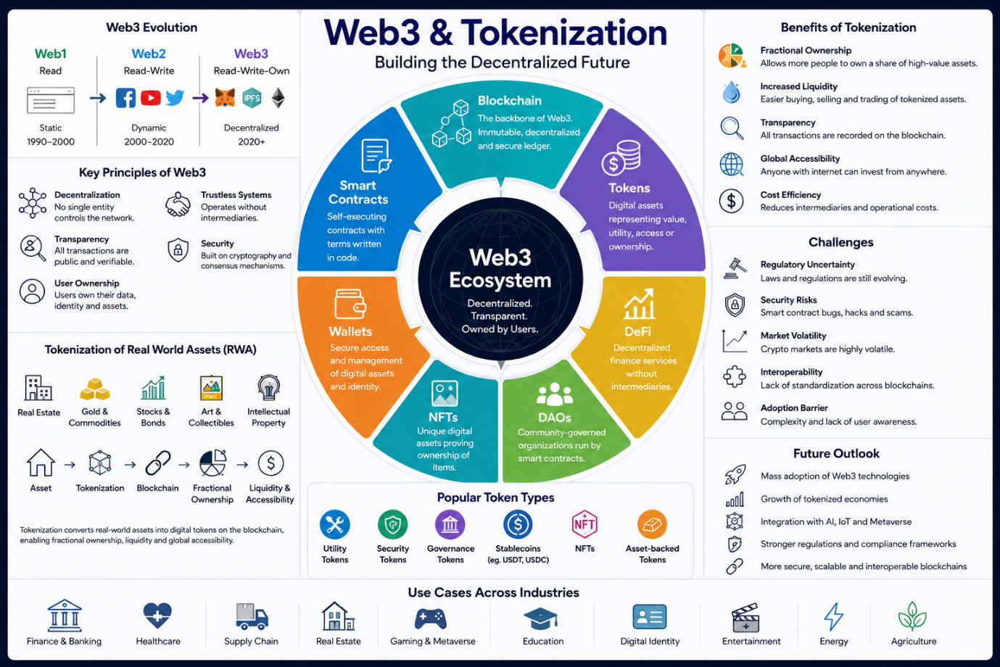

1. Introduction to Web3
- Define Web3 and explain its evolution from Web1 and Web2.
- Core principles of Web3:
  - Decentralization
  - Blockchain technology
  - Smart contracts
  - Transparency
  - User ownership
- Differences between centralized and decentralized systems.
- Importance of Web3 in the modern digital economy.
2. Blockchain Fundamentals
- Explain blockchain architecture and working.
- Types of blockchains:
  - Public
  - Private
  - Consortium
  - Hybrid
- Consensus mechanisms:
  - Proof of Work (PoW)
  - Proof of Stake (PoS)
  - Delegated Proof of Stake (DPoS)
- Role of nodes, miners, validators, and wallets.
3. Smart Contracts
- Definition and functionality of smart contracts.
- Popular smart contract platforms:
  - Ethereum
  - Solana
  - Polygon
  - Binance Smart Chain
- Programming languages used:
  - Solidity
  - Rust
- Advantages and limitations of smart contracts.
- Security vulnerabilities and attack examples.
4. Tokenization
- Define tokenization in Web3.
- Difference between coins and tokens.
- Types of tokens:
  - Utility tokens
  - Security tokens
  - Governance tokens
  - Stablecoins
  - Non-Fungible Tokens (NFTs)
  - Asset-backed tokens
- Token standards:
  - ERC-20
  - ERC-721
  - ERC-1155
- Token creation and lifecycle.
5. Real-World Asset (RWA) Tokenization
- Tokenization of:
  - Real estate
  - Gold and commodities
  - Stocks and bonds
  - Intellectual property
  - Art and collectibles
- Benefits:
  - Fractional ownership
  - Liquidity
  - Transparency
  - Global accessibility
- Challenges:
  - Regulation
  - Legal ownership
  - Security risks
  - Market volatility
6. Decentralized Finance (DeFi)
- Explain DeFi ecosystem and protocols.
- Lending and borrowing platforms.
- Decentralized exchanges (DEXs).
- Yield farming and staking.
- Liquidity pools and automated market makers (AMMs).
- Risks in DeFi systems.
7. NFTs and Digital Ownership
- NFT technology and metadata storage.
- Use cases:
  - Gaming
  - Art
  - Music
  - Identity systems
  - Ticketing
- NFT marketplaces and ecosystems.
- Copyright and ownership concerns.
8. DAOs (Decentralized Autonomous Organizations)
- Definition and working mechanism.
- Governance models using tokens.
- Voting systems in DAOs.
- Examples of successful DAOs.
- Advantages and governance challenges.
9. Security and Privacy in Web3
- Common attacks:
  - Rug pulls
  - Phishing
  - Smart contract exploits
  - 51% attacks
- Wallet security mechanisms.
- Privacy-focused blockchains and technologies.
- Regulatory compliance and cybersecurity practices.
10. Legal and Regulatory Aspects
- Global regulations around Web3 and crypto assets.
- KYC and AML requirements.
- Government responses in different countries.
- Taxation of digital assets.
- Legal concerns in tokenized assets and securities.
11. Business Applications and Industry Use Cases
Research Web3 and tokenization applications in:
- Banking and finance
- Healthcare
- Supply chain management
- Agriculture
- Education
- Real estate
- Gaming and metaverse
- Digital identity systems
12. Emerging Trends and Future Scope
- Web3 AI integration
- Tokenized economies
- Metaverse ecosystems
- Interoperability between blockchains
- Layer-2 scaling solutions
- CBDCs (Central Bank Digital Currencies)
- Future challenges and adoption barriers
13. Case Studies
Include detailed case studies of:
- Ethereum
- OpenSea
- Chainlink
- Polygon
- Uniswap
- Real-world tokenized asset platforms
14. Comparative Analysis
Provide comparisons between:
- Web2 vs Web3
- Traditional finance vs DeFi
- Traditional ownership vs tokenized ownership
- Centralized apps vs decentralized apps (dApps)
15. Conclusion
- Summarize key findings.
- Discuss opportunities and risks.
- Analyze the future impact of Web3 and tokenization on global industries and society.
Additional Requirements
- Include diagrams and architecture explanations where applicable.
- Add recent statistics, market trends, and adoption data.
- Use credible sources such as research papers, industry reports, whitepapers, and official blockchain documentation.
- Include references and citations in IEEE or APA format.
- Explain technical concepts in simple language along with advanced insights.
- Include both advantages and limitations objectively.

